**Lab-10**

**Alpha Beta purning**

1. Tic tac toe

import math

# ----------- GAME LOGIC ------------

def print_board(board):

print("\n")

for i in range(3):

print(" | ".join(board[i*3:(i+1)*3]))

if i < 2:

print("--+---+--")

print("\n")

def check_winner(board):

"""Return 'X' or 'O' if there is a winner, or None otherwise."""

win_combos = [

[0,1,2], [3,4,5], [6,7,8], # rows

[0,3,6], [1,4,7], [2,5,8], # columns

[0,4,8], [2,4,6] # diagonals

]

for combo in win_combos:

if board[combo[0]] == board[combo[1]] == board[combo[2]] and board[combo[0]] != ' ':

return board[combo[0]]

return None

def is_full(board):

return ' ' not in board

# ----------- ALPHA-BETA PRUNING ------------

def minimax(board, depth, alpha, beta, maximizing):

winner = check_winner(board)

if winner == 'O': # AI wins

return 1

elif winner == 'X': # Human wins

return -1

elif is_full(board): # Draw

return 0

if maximizing:

max_eval = -math.inf

for i in range(9):

if board[i] == ' ':

board[i] = 'O'

eval = minimax(board, depth + 1, alpha, beta, False)

board[i] = ' '

max_eval = max(max_eval, eval)

alpha = max(alpha, eval)

if beta <= alpha:

break

return max_eval

else:

min_eval = math.inf

for i in range(9):

if board[i] == ' ':

board[i] = 'X'

eval = minimax(board, depth + 1, alpha, beta, True)

board[i] = ' '

min_eval = min(min_eval, eval)

beta = min(beta, eval)

if beta <= alpha:

break

return min_eval

def best_move(board):

best_val = -math.inf

move = -1

for i in range(9):

if board[i] == ' ':

board[i] = 'O'

move_val = minimax(board, 0, -math.inf, math.inf, False)

board[i] = ' '

if move_val > best_val:

best_val = move_val

move = i

return move

# ----------- GAME LOOP ------------

def play_game():

board = [' ' for _ in range(9)]

print("Welcome to Tic-Tac-Toe with Alpha-Beta Pruning!")

print_board(board)

print("You are 'X'. AI is 'O'. Enter positions 1-9 as below:")

print("1 | 2 | 3\n--+---+--\n4 | 5 | 6\n--+---+--\n7 | 8 | 9\n")

while True:

# Human move

while True:

try:

move = int(input("Enter your move (1-9): ")) - 1

if move < 0 or move > 8 or board[move] != ' ':

print("Invalid move. Try again.")

else:

board[move] = 'X'

break

except ValueError:

print("Please enter a valid number between 1 and 9.")

print_board(board)

if check_winner(board):

print("You win! 🎉")

break

if is_full(board):

print("It's a draw!")

break

# AI move

print("AI is thinking...")

ai_move = best_move(board)

board[ai_move] = 'O'

print_board(board)

if check_winner(board):

print("AI wins! 💻")

break

if is_full(board):

print("It's a draw!")

break

# ----------- RUN GAME ------------

if __name__ == "__main__":

play_game()

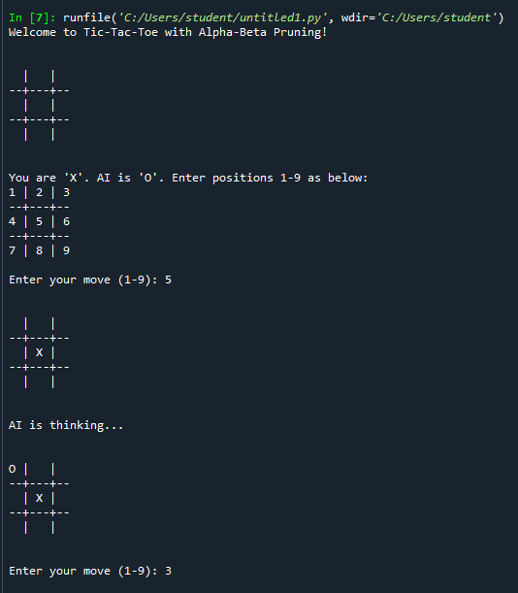 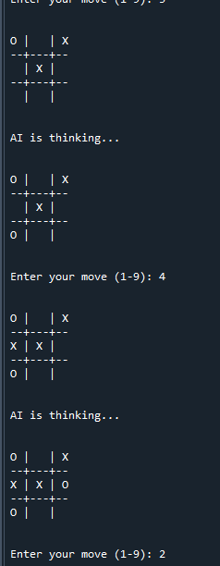 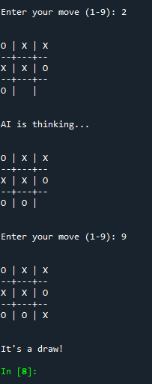

1. 8 puzzle game

import heapq

goal_state = [

[1, 2, 3],

[4, 5, 6],

[7, 8, 0] # 0 represents the blank tile

]

# --- Helper functions ---

def find_blank(board):

for i in range(3):

for j in range(3):

if board[i][j] == 0:

return i, j

def manhattan_distance(board):

distance = 0

for i in range(3):

for j in range(3):

value = board[i][j]

if value != 0:

goal_i, goal_j = divmod(value - 1, 3)

distance += abs(i - goal_i) + abs(j - goal_j)

return distance

def get_neighbors(board):

neighbors = []

i, j = find_blank(board)

moves = [(1,0), (-1,0), (0,1), (0,-1)]

for di, dj in moves:

new_i, new_j = i + di, j + dj

if 0 <= new_i < 3 and 0 <= new_j < 3:

new_board = [row[:] for row in board]

new_board[i][j], new_board[new_i][new_j] = new_board[new_i][new_j], new_board[i][j]

neighbors.append(new_board)

return neighbors

def board_to_tuple(board):

return tuple(tuple(row) for row in board)

def print_board(board):

for row in board:

print(" ".join(str(x) if x != 0 else '_' for x in row))

print()

# --- A* Search Algorithm ---

def a_star(start):

open_set = []

heapq.heappush(open_set, (manhattan_distance(start), 0, start))

came_from = {}

g_score = {board_to_tuple(start): 0}

visited = set()

while open_set:

_, cost, current = heapq.heappop(open_set)

if current == goal_state:

# Reconstruct path

path = [current]

while board_to_tuple(current) in came_from:

current = came_from[board_to_tuple(current)]

path.append(current)

path.reverse()

return path

visited.add(board_to_tuple(current))

for neighbor in get_neighbors(current):

tentative_g = g_score[board_to_tuple(current)] + 1

neighbor_tup = board_to_tuple(neighbor)

if neighbor_tup in visited:

continue

if tentative_g < g_score.get(neighbor_tup, float('inf')):

came_from[neighbor_tup] = current

g_score[neighbor_tup] = tentative_g

f_score = tentative_g + manhattan_distance(neighbor)

heapq.heappush(open_set, (f_score, tentative_g, neighbor))

return None # No solution

# --- Main Program ---

if __name__ == "__main__":

print("Enter initial 8-puzzle configuration (use 0 for blank):")

start = []

for i in range(3):

row = list(map(int, input(f"Row {i+1}: ").split()))

start.append(row)

print("\nSolving...\n")

solution_path = a_star(start)

if solution_path:

print(f"✅ Solution found in {len(solution_path)-1} steps.\n")

for step, board in enumerate(solution_path):

print(f"Step {step}:")

print_board(board)

else:

print("❌ No solution exists for this puzzle.")

